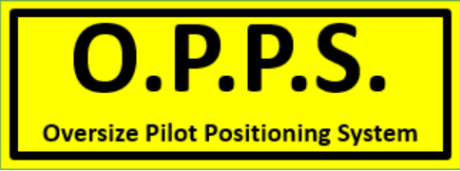

**UPDATE - RAILWAY CROSSING NUMBERS (SA)**

Australian Rail Track Corporation (ARTC) has updated their phone numbers for SA.

**Yorkies Crossing PH 08 8152 8006**

**Train Control West PH 08 8152 8007**

**(Footner Road Crossing – Pt Augusta)**

UPDATED: 27/01/23